Name: __________________________________ Page #_________

Tobacco Station Notes

Directions: Using the information at each station, answer the questions

**Station 1: Harmful Products found in Tobacco**

NOTE: use the textbook pgs.____________ and the laminated handout at your table to answer the questions below

1. What is the addictive substance in Tobacco called? __**nicotine**____________________

~it takes only 7-10 seconds for it to reach the brain after it is inhaled.

2. What is Tar and what does it do to the lungs? (see model to check out what tar looks like)

**A thick, oily substance formed when tobacco is burned.**

~What health problems are caused by tar?

**Lung Cancer, emphysema, bronchitis.**

3. What is Carbon Monoxide? **A poisonous, colorless, odorless gas**

~What health problems are caused by Carbon monoxide? **Heart Attack/Stroke/High Blood Pressure**

4. Define Carcinogen: **A cancer causing chemical/substance.**

Name 5 carcinogens and what else they can be found in: (see laminated handout)

Example: Benzene-also found in gasoline

**Arsenic - found in rat poison Vinyl Chloride - plastic pipe**

**Acetone - nail polish remover**

**Cadmium-found in batteries**

**Station 2: Health Risks from Tobacco Use:**

*Using the website <https://teens.drugabuse.gov/drug-facts/tobacco-nicotine-e-cigarettes>

OR the handouts located at your table, identify how tobacco can harm the body. Draw an arrow to at least 8 body parts, and label the way the body part can be affected. For example, draw an arrow to the lungs and list what diseases can be caused by smoking. 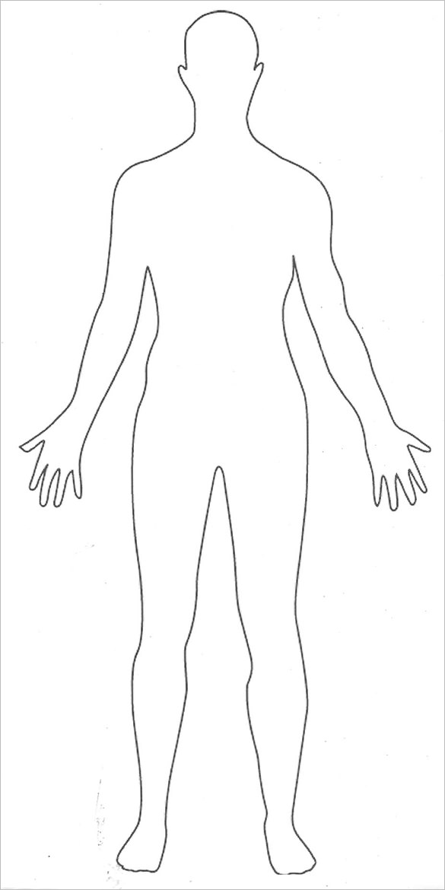

**Station 3: Second Hand Smoke:**

1. Where does second hand smoke come from? HINT: give the 2 forms

1. **Smoke that comes off end of a burning cigarette**
2. **Smoke exhaled from smokers lungs**

2. Give at least 5 dangers of second hand smoke: (what diseases can it be linked to, etc.)

**Lung Cancer Ear infections**

**Heart Disease Colds**

**Asthma Other Cancers**

**Stroke**

3. Give at least 5 tips to avoid second hand smoke

1. **Ask people not to smoke in your car or home**
2. **Avoid places that allow indoor smoking**
3. **Choose smoke free restaurants**
4. **Set up an outdoor area if you live with a smoker**
5. **Discuss health risks with the smoker to encourage them not do it around you**

4. Explain what “3rd hand smoke” is:

**The toxins left behind from smoke that sticks to soft surfaces (upholstery, rugs, curtains, etc.)**

**Station 4: How smoking effects personal appearance:**

1. Using the article at your table, list at least 5 ways that smoking could affect a person’s appearance AND explain how. Afterward, go to the computer to play the “Effects of Smoking” game.

1. **stained teeth - fingers -from nicotine**
2. **thinning hair- tobacco changes DNA in hair follicles**
3. **scarring - body can’t heal itself as quickly due to reduced blood flow**
4. **tooth loss - tobacco increases chance of cavities and tooth decay**
5. **Bags under eyes - from nicotine withdrawal, causing sleep disruptions**

**Station 5: Smoking During Pregnancy:**

Using the infographic, answer the following questions, then complete the straw activity to imagine how it must feel to be robbed of oxygen

1. What health risks could an unborn child face if the mother smokes while pregnant?

**\*born prematurely *respiratory diseases (asthma, etc.)**

**\*risk of still birth *risk of SIDS (Sudden Infant Death Syndrome)**

**\*low birth weight**

2. Why does smoking do that to the fetus (the growing baby)

**\*it lowers the oxygen available to baby (from placenta)**

**\*lowers nutrients**

3. After the mom gives birth, why is it still harmful for her to smoke around her baby and children?

**\*more frequent ear infections, colds, flu**

**\*risk of ADHD**

**\*asthma, higher risk of infection**

* **SIDS**

**Station 6: Ways to Quit Smoking/Smoking Cessation**

1.Define withdrawl (note: use the textbook glossary to answer this):

**The physical and psychological reactions that occur when someone stops using an addictive substance.**

2. Is it easy to quit smoking? __**NO**_____

On average, how many attempts do most people have to take before they are successful in quitting tobacco?

**5-7 attempts**

3. Name at least 4 popular methods to quit smoking and explain how they work:

1. Cold turkey - suddenly stopping relying on willpower to quit
2. Nicotine Replacement Therapy - methods like the patch or gum to slowly quit over time
3. Prescription Drugs - Zybon or Chantix work on brain chemicals that cause addiction
4. Hypnosis - Helps deal with cravings when unconscious

4. Using the infographic, explain what happens to the body after quitting for:

2 weeks: **Lung function begins to improve**

1 year: **Risk of Heart Disease is ½ of a smoker’s risk**

10 years: **Risk of dying of lung cancer is half of a smokers.**

**Station 7: Smokeless Tobacco**

Using the “Quit the Spit” article as well as clues from the word bank, fill in the chart below, than discuss the questions about smokeless tobacco with your group. Questions are on the index cards

What are the different forms of smokeless tobacco and how are they used?

Chew, Snuff, Dip. User places between cheek and gum and nicotine is absorbed through mucus membranes of the mouth.

2. Are these a safe alternative to smoking?

NO!

3. Is smokeless tobacco addictive?

YES! One canister is equivalent to approximately 3 packs of cigarettes.

4. What diseases/conditions can smokeless tobacco cause?

-Gum Disease

-Oral Cancers

-Heart Disease/Stroke

-Cancers of the tongue, cheek, throat, etc.